How have I learned,
Collaboration discussion in where I could learn from my class mates as people have different perspective and usually provide different solutions for the same problem. For example in Unit 7 Collaborative Discussion 3, I provided a solution for secure user management system using Bcrypt password hashing function but after studying my classmates refactor and conducting further research I decided to adopt Argon2. Argon2 won the Password Hashing Competition and is widely recommended in academic and professional guidance because of its memory‑hard design, which makes brute‑force attacks significantly more expensive (Biryukov, Dinu & Khovratovich, 2016).
Self-study using provided resources on university learning platform such as lectureCasts (provide a screenshot of a finishing lecture cast), and reading references provided in each Units such as Modern Python Cookbook, Discovering Cybersecurity: A Technical Introduction for the absolute Beginner, Introduction to Responsible AI: Implement Ethical AI Using Python, and so on.
Seminars in which my tutor kindly and supportively provided us with information and knowledge to help us to understand the most important concepts and make our learning path easier even though he was not at the complete health status. My tutor also upload our seminars and associated exercises on our learning platform that was a great reference for me to return and master the concepts that I could not completely understand during the seminar or our tutor could not provided them due to lack of time.
Due to the fact of being a non-native speaker using Google search (AI mode), ChatGPT ,and Microsoft Copilot as my assistants were real asset to search, understand and master or comprehend the concepts, key words, and even English vocabulary.
Doing all the exercises and formative assignments and practicing Python code writing using JetBrains PyCharm Integrated Development Environment (IDE) to improve my coding skills and moreover seeing the concept in reality which was real help to master all concepts and materials of the module

References
Biryukov, A., Dinu, D., & Khovratovich, D. (2016). Argon2: The memory-hard function for password hashing and other applications.

Appendices

Unit 8 - Collaborative Discussion 4

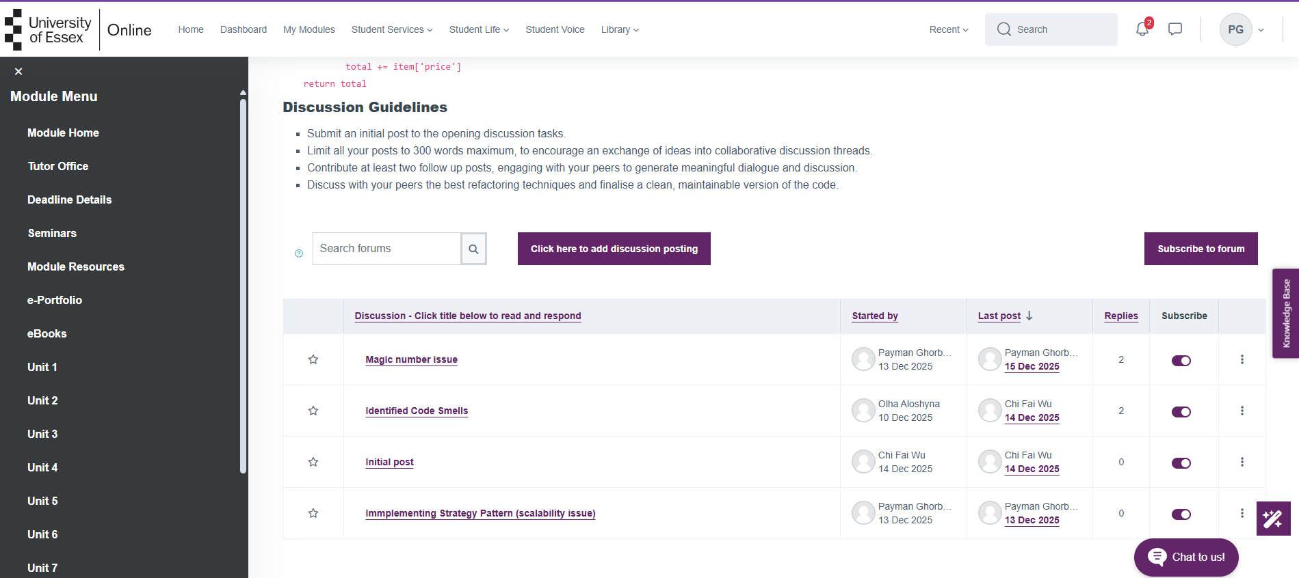
Unit 7 – Collaborative Discussion 3

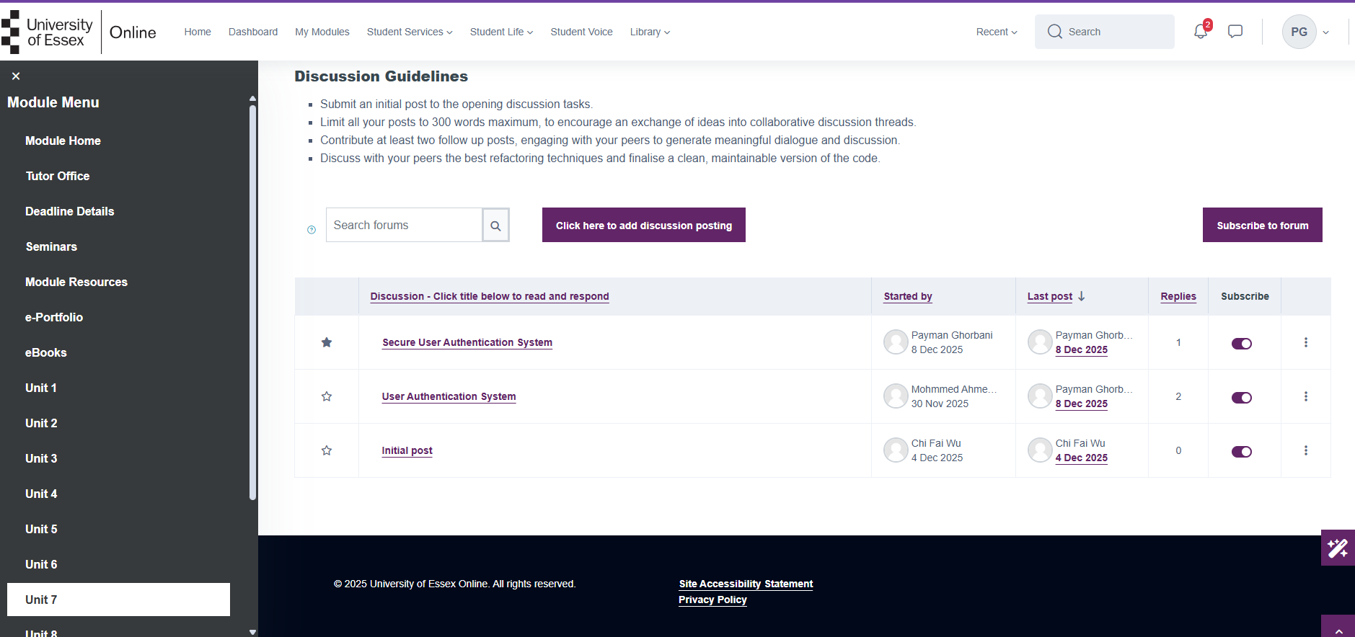

Learning from classmates evidance
